NRE-1/ FCPS-1 / JCAT
Medicine & Allied
Cardiovascular System (CVS)
Acute Chest Pain

MCQ 2 – Aortic Dissection History
Exam Appearance: NRE-1, Pakistan, Oct 2021

Question Id: 502039
Q 02: A 60-year-old man with a history of hypertension presents with sudden, severe chest pain described as tearing. The pain started abruptly while he was at rest. Which historical feature most strongly supports a diagnosis of aortic dissection? (Question Id: 502039)
- Pain relieved by lying down
- Pain described as pressure
- Pain associated with meals
- Pain worsened by inspiration
- Pain radiating to the back
ANSWER: E

Keywords in the Stem to identify correct option
- Sudden – Indicates an acute, emergency condition like aortic dissection rather than gradual causes (GERD, pericarditis).
- Tearing pain – Classic descriptive term strongly associated with aortic dissection.
- Hypertension – Major risk factor predisposing to aortic dissection.
Classic Triad
- Not explicitly in the stem. The classic triad for aortic dissection is:
  - Abrupt, severe chest pain
  - Pain radiating to the back
  - Pulse or blood pressure differential between limbs
Here, the stem gives 2 of 3 elements (abrupt severe tearing pain + hypertension as a risk factor), which points toward aortic dissection.

Explanation

(Option E) Pain radiating to the back:
- This is the strongest historical feature listed that supports aortic dissection, especially in the setting of severe, sudden, and tearing chest pain. The aorta's path (especially the descending aorta in a Type B dissection or the extension of a Type A dissection) runs along the spine. As the dissection flap tears, it often causes pain that radiates directly to the back (interscapular area) due to the involvement of the descending aorta and its proximity to the posterior structures.
- This type of radiation, along with the tearing quality, is the most specific combination for this diagnosis.
- Often associated with hypertension and may be accompanied by pulse deficits or blood pressure differences between arms.
- This historical feature helps differentiate aortic dissection from MI, pericarditis, pleuritis, or GI causes.

(Option A) Pain relieved by lying down:
- Typically suggests pericarditis or musculoskeletal chest pain.
- Pericardial pain often improves when the patient sits up or leans forward, not a feature of aortic dissection.
(Option B) Pain described as pressure:
- Classic for myocardial ischemia (angina or MI).
- Pressure or squeezing pain is usually retrosternal and may radiate to the jaw or left arm, unlike tearing pain radiating to the back.
(Option C) Pain associated with meals:
- Suggests a gastrointestinal origin, e.g., gastroesophageal reflux disease (GERD) or peptic ulcer.
- Pain is often gradual, positional, or related to eating, not sudden and tearing.
(Option D) Pain worsened by inspiration:
- Suggests pleuritic pain, e.g., pulmonary embolism, pneumothorax, or pleuritis.
- Typically sharp, increases with deep breaths, unlike the sudden tearing pain of aortic dissection.

Key Concept
Aortic dissection typically presents with sudden, severe, tearing chest pain that radiates to the back. Recognizing the pattern and radiation of pain is critical for differentiating it from myocardial infarction, pericarditis, pleuritic, or gastrointestinal causes.

Category: FCPS-1/ JCAT
Product: Medicine & Allied
System: Cardiovascular System
Topic: Acute Chest Pain
Sub-Topic: History and Presentation
MCQ Title: Aortic Dissection – Clinical Presentation

- Competency Domain: Diagnosis
- Cognitive Level: Application
- Clinical Skill: Reasoning
- Difficulty Level: Moderate

Aortic Dissection – Clinical Presentation
Feature | Description | Clinical Relevance / Differentiation
Pain | - Sudden,  - severe,  - tearing or ripping chest pain | - Classic symptom;  - distinguishes from MI (pressure) or pericarditis (positional)
Radiation | - Often to the back,  - interscapular region, or  - abdomen | Key clue supporting aortic involvement
Risk Factors / History | - Hypertension,  - connective tissue disorders (Marfan, Ehlers-Danlos),  - older age | Identifies high-risk patients
Vital Signs / Pulse | - Hypertension,  - pulse deficits,  - BP difference between arms | - Supports diagnosis;  - part of classic triad
Associated Symptoms | - Syncope,  - dyspnea,  - neurological deficits | May indicate complications like aortic rupture or stroke
Key Concept
Sudden, severe, tearing chest pain radiating to the back in a hypertensive patient is highly suggestive of aortic dissection.

Differential Diagnosis of Acute Chest Pain:
Key Features and Distinguishing Points
Condition | Key Features / Pain Type | Differentiating Points from Aortic Dissection
Acute Myocardial Infarction (MI) | - Pressure,  - heaviness,  - squeezing retrosternal pain | - Pain radiates to left arm/jaw;  - ECG changes;  - troponin elevated;  - less tearing quality
Pericarditis | - Sharp,  - positional pain,  - relieved by leaning forward | - ECG shows diffuse ST elevation;  - pain improves with posture;  - no back radiation
Pulmonary Embolism | - Sudden pleuritic pain,  - dyspnea,  - hemoptysis | - Pain worsens with inspiration;  - risk factors for DVT;  - tachycardia;  - imaging shows embolus
Pneumothorax | - Sudden unilateral pleuritic pain,  - dyspnea | - Reduced breath sounds on one side;  - no tearing radiation;  - confirmed by chest X-ray
Gastroesophageal Reflux Disease (GERD) /  Esophageal Spasm | - Burning,  - epigastric pain related to meals | - Positional or post-prandial;  - relieved by antacids;  - lacks sudden tearing/back radiation
Aortic Rupture / Trauma | - Sudden excruciating pain,  - hypotension | - Often post-trauma;  - rapid collapse;  - may coexist with dissection
Key Concept
Acute tearing chest pain radiating to the back in a hypertensive patient is most consistent with aortic dissection, but MI, pericarditis, pulmonary embolism, pneumothorax, and GI causes are common differentials that must be ruled out quickly.

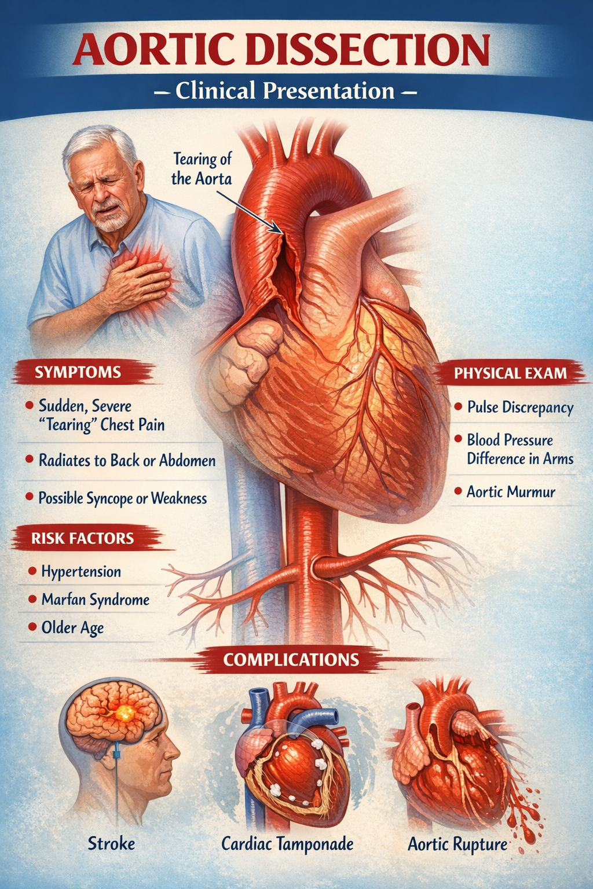

Aortic Dissection – Clinical Presentation
This diagram illustrates the key clinical features of aortic dissection, highlighting sudden, severe tearing chest pain radiating to the back as the hallmark symptom. It also demonstrates important risk factors (hypertension, older age, connective tissue disorders), physical findings (pulse deficit, BP discrepancy), and major life-threatening complications such as stroke, cardiac tamponade, and aortic rupture, emphasizing the need for rapid recognition and emergency management.

